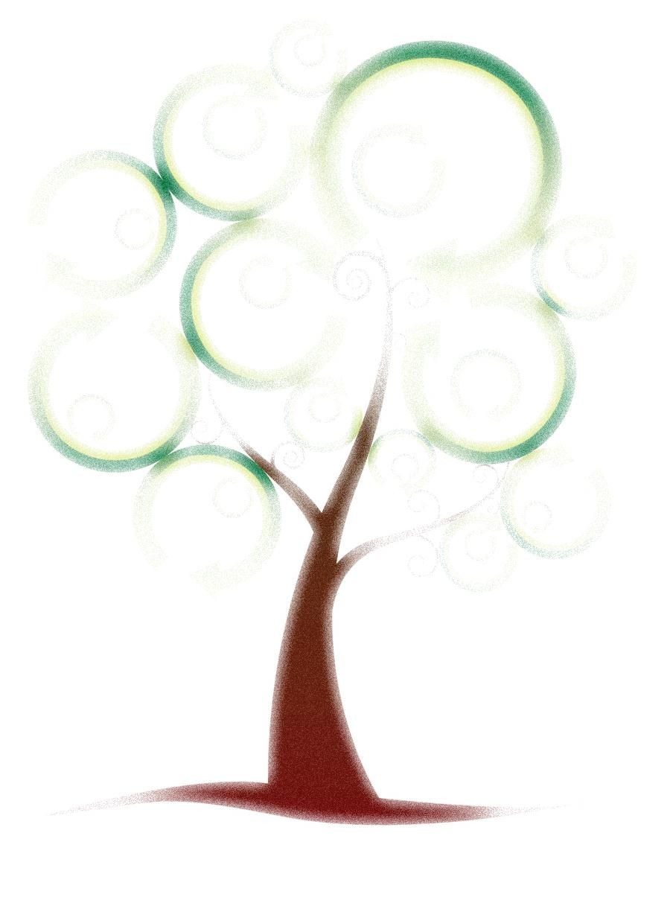
3 R’s
By Jack Johnson (Bushfire Records, 2006)
Three it's a magic number
Yes it is, it's a magic number
Because two times three is six
And three times six is eighteen
And the eighteenth letter in the alphabet is R
We've got three R's we're going to talk about today
We've got to learn to
Reduce, Reuse, Recycle
Reduce, Reuse, Recycle
Reduce, Reuse, Recycle
Reduce, Reuse, Recycle
If you're going to the market to buy some juice
You've got to bring your own bags and you learn to reduce your waste
And if your brother or your sister's got some cool clothes
You could try them on before you buy some more of those
Reuse, we've got to learn to reuse
And if the first two R's don't work out
And if you've got to make some trash
Don't throw it out
Recycle, we've got to learn to recycle,
We've got to learn to
Reduce, Reuse, Recycle
Reduce, Reuse, Recycle
Reduce, Reuse, Recycle
Reduce, Reuse, Recycle
Because three it's a magic number
Yes it is, it's a magic number
3, 3, 3
3, 6, 9, 12, 15, 18, 21, 24, 27, 30, 33, 36
33, 30, 27, 24, 21, 18, 15, 12, 9, 6, and
3, it's a magic number

